# CS 255 System Design Document Template

## UML Diagrams

### UML Use Case Diagram

*[In Module Six, you were asked to complete a use case diagram based on your system design. If you would like to make any adjustments to your diagram, please do so. Please insert your use case diagram here. Check to make sure that you included appropriate components and symbols and that your design meets the client’s needs.]*

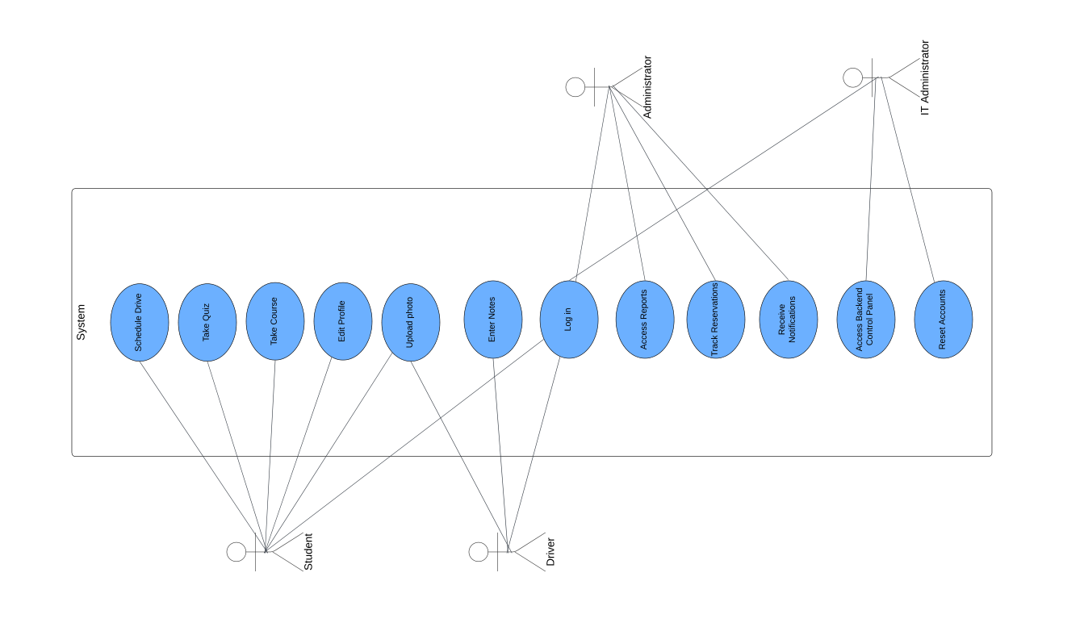

### UML Activity Diagrams

*[You were asked to choose* ***two*** *use cases and create* ***two*** *activity diagrams, one for each use case. Please insert* ***both*** *of your activity diagrams here. Check to make sure that you included appropriate components and symbols and that your design meets the client’s needs.]*

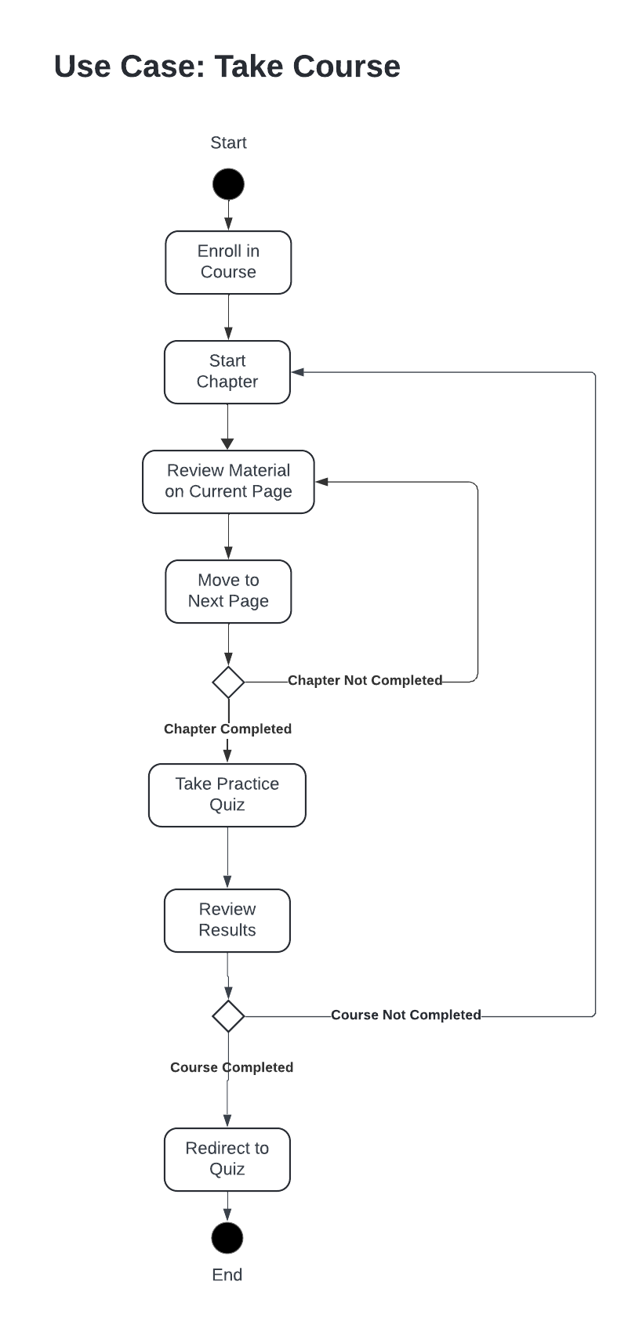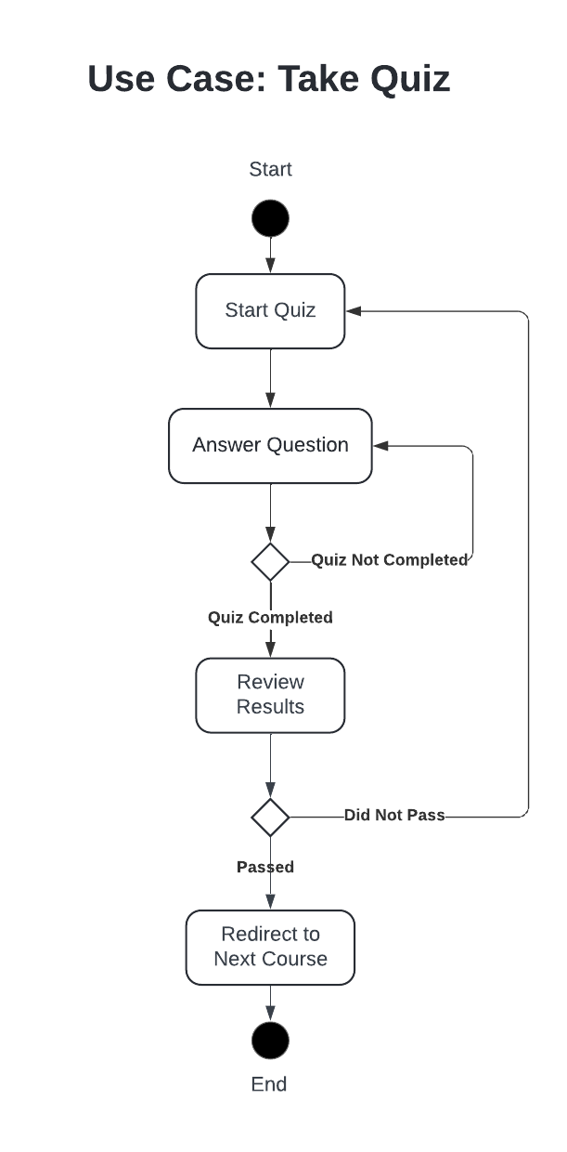

### UML Sequence Diagram

*[You were asked to create a sequence diagram based on* ***one*** *of the use cases you chose. Please insert your sequence diagram here. Check to make sure that you included appropriate components and symbols and that your design meets the client’s needs.]*

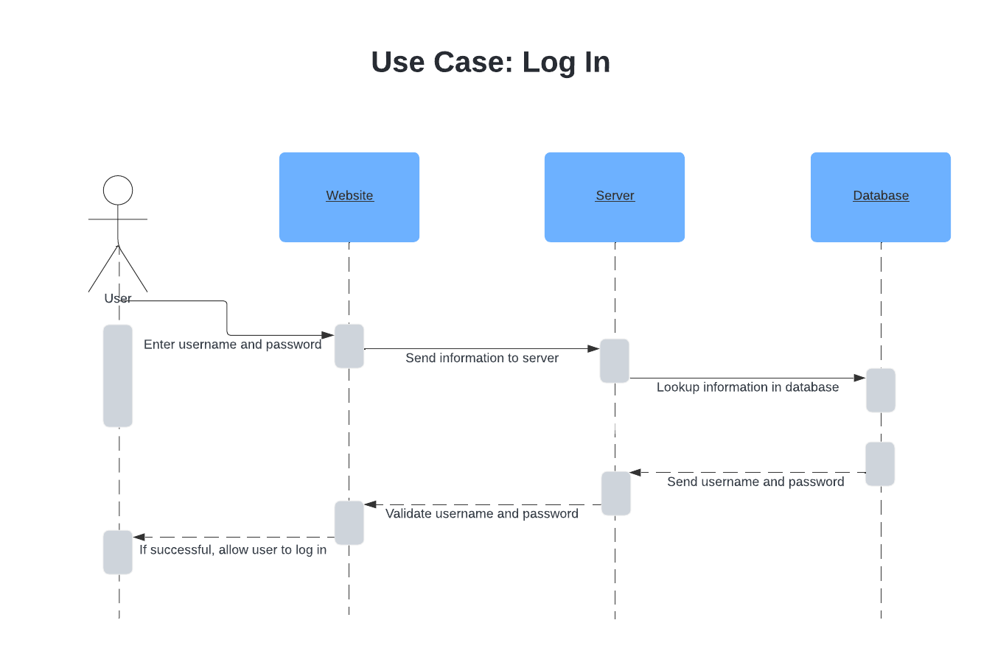

### UML Class Diagram

*[You were asked to create a class diagram based on the different classes and attributes needed for your system design. You are* ***not*** *required to include methods, but you may if you wish. Please insert your class diagram here. Check to make sure that you included appropriate components and symbols and that your design meets the client’s requirements.]*

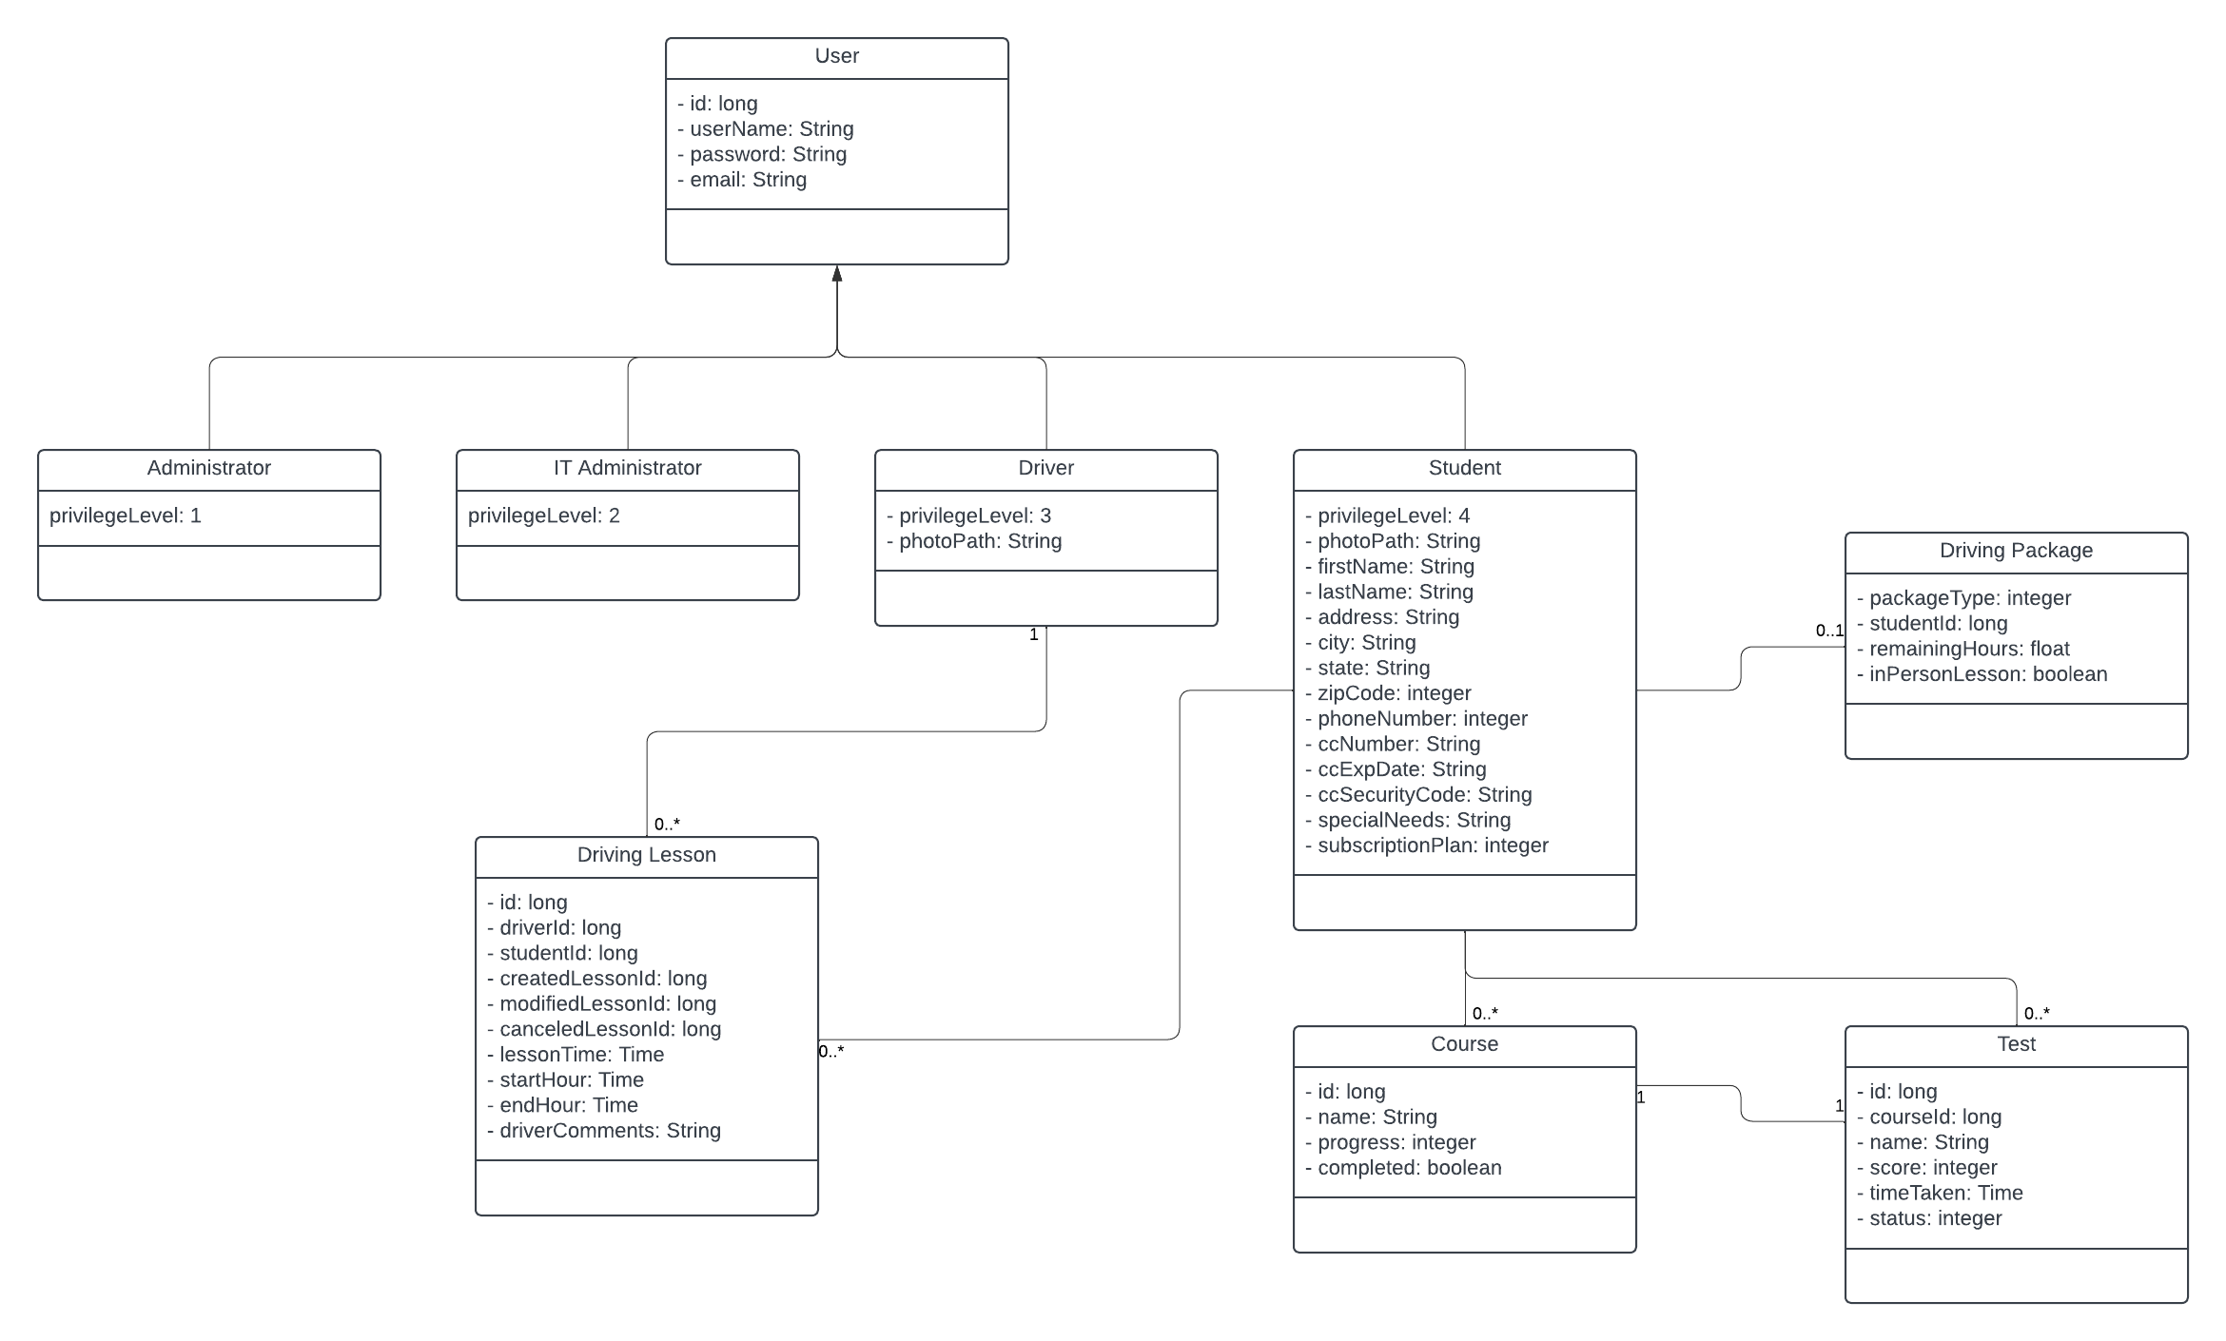

## Technical Requirements

*[Based on the diagrams you have created, describe the technical requirements of your system. These requirements should address the required hardware, software, tools, and infrastructure necessary for your system design.]*

To create this system, DriverPass will need at least one server with uninterrupted access to the Internet. The server will need networking supplies such as cables and a router. If the server is a desktop workstation, it will need a monitor, keyboard, and mouse. The company must register for a website domain to host their web application.

The server will need to run a server operating system, such as Microsoft Windows Server, and its security and networking will need to be appropriately configured to run the web application securely.

Tools such as IDEs, a version control system, package managers, and build tools will be required. Examples are Visual Studio or Eclipse, Git, and Webpack. Frameworks and libraries such as React, Node.js, and Spring may be used to expedite development. A SQL database management system (DBMS) such as PostgreSQL will also be required. Jest could be used for unit testing, or Cypress could be used for end-to-end testing. Collaboration tools such as Jira and Slack can also help teams communicate effectively. Docker can be used for containerization during production.

Since the web application will be cloud-based, DriverPass could host their application on a cloud-based provider such as AWS or Microsoft Azure.

Clients will need a modern computing device, such as a desktop computer, laptop, or mobile device, and broadband Internet access to use the web application.